Table of Content

1 . Adding a server 2

2. The server panel 4

2. Adding a Session 6

3. Managing tables 7

4. Handling Contexts 10

# 1 . Adding a server

Right click on the servers window, a pop-up menu shows which allows you to add a new server, remove an existing one and disconnect from a server.

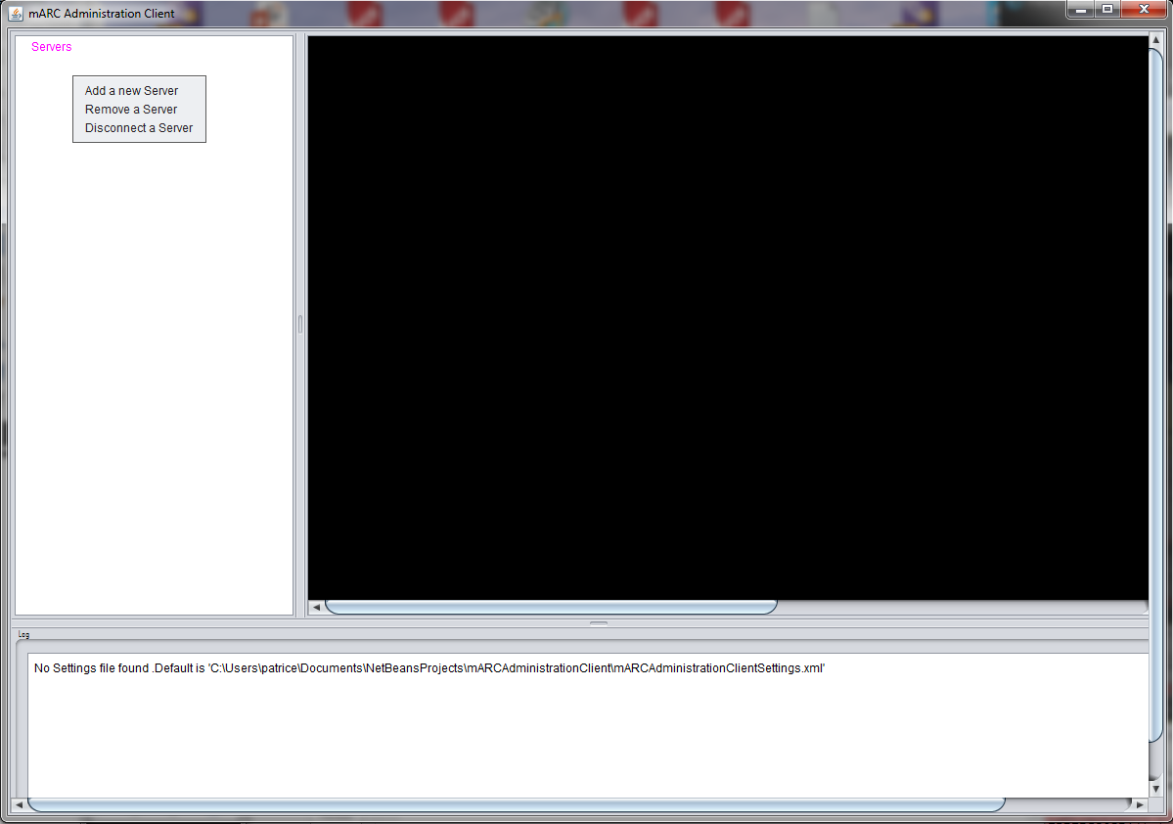

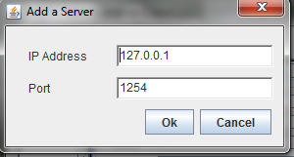A new window shows in:

Fill in the connection information to obtain:

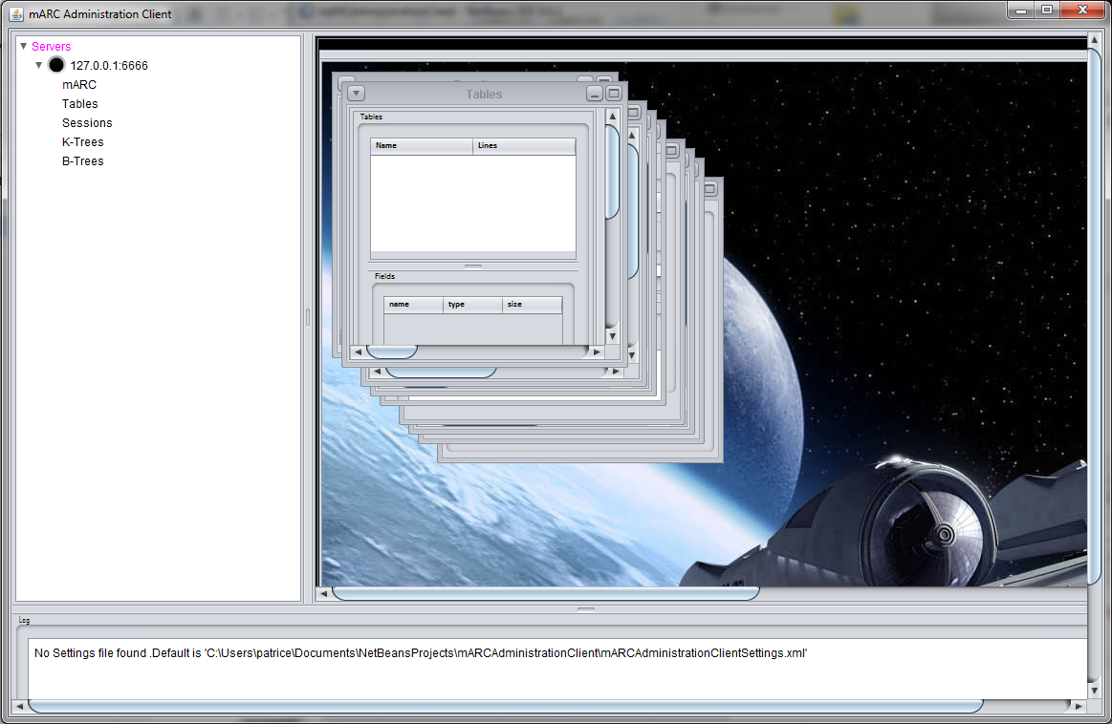

The server is shown on the left window. To connect to it just left click on the black led:

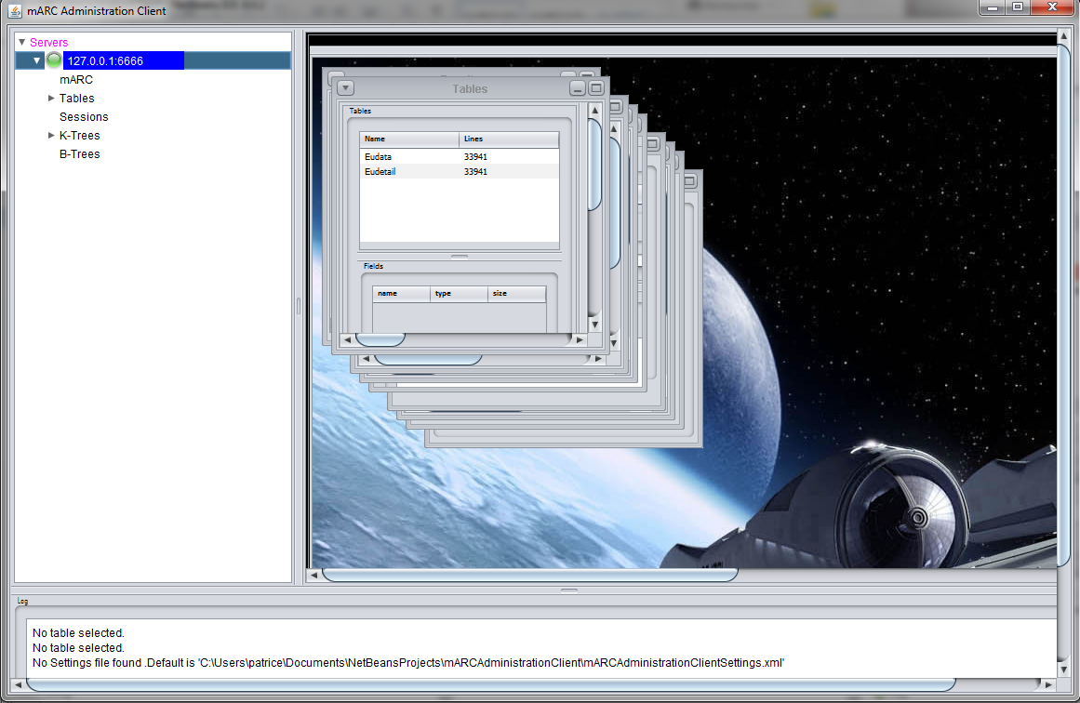

The led turns green. Next step is to add a session. You can see on the desktop panel (right panel), windows which allow you to interact with the server.

# 2. The server panel

Sliding down the desktop panel, you access the server panel which displays real time information about the remote server.

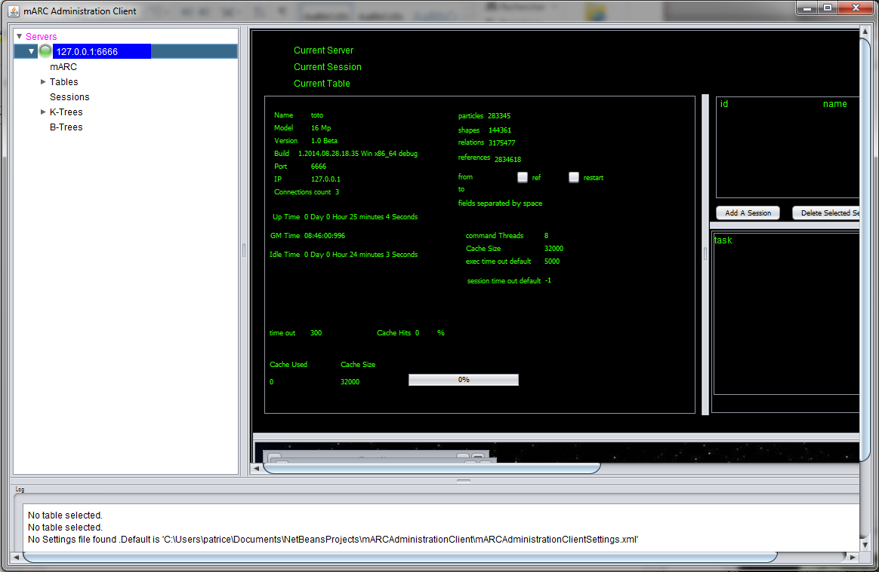

Clicking right on the “mARC” node on the left tree of the main window, you access the contextual menu allowing you to execute basic operations on the knowledge:

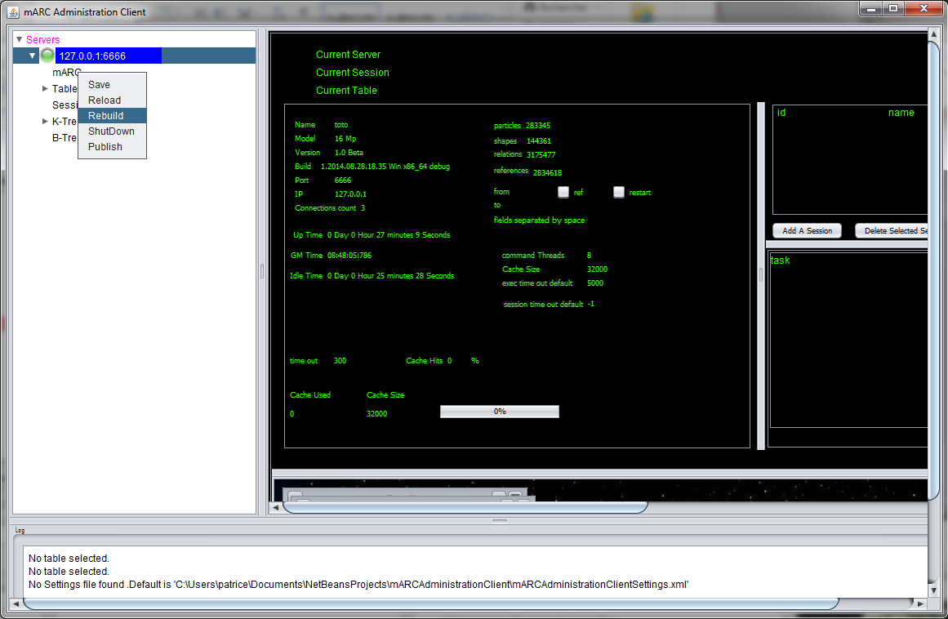

“ShutDown” and “Rebuild” need parameters. These parameters are located in the middle of the server panel:

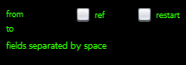

The checkbox “restart” is the parameter attached to the “ShutDown” operation and allows the server to restart after shutdown.

Left clicking on “from” and “to” allow you to specify the start and end and option “ref” (to perform indexation during learning) parameters of the “Rebuild” operation while clicking on “fields separated by space” allows you to specify the fields on which the rebuild process will act:

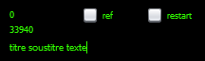

# 2. Adding a Session

There are two ways:

* Right click on the “Sessions” node in the tree on the left:

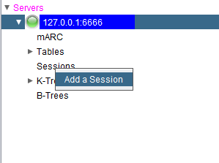

* Click on the “Add session” button in the server panel.

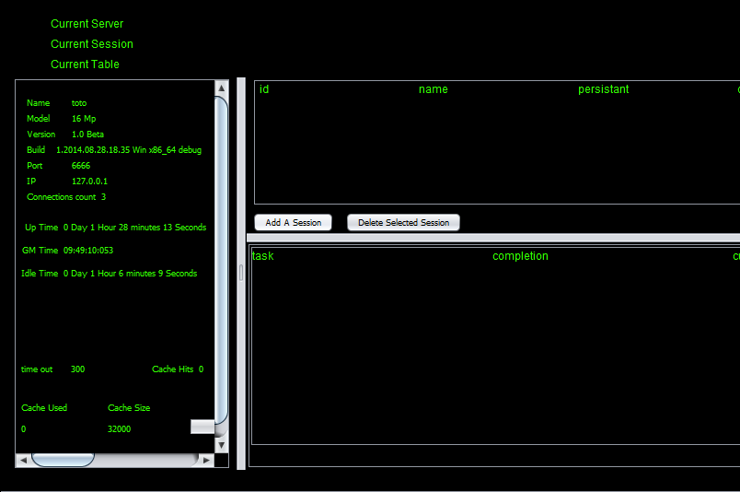

The “Session” tab contains two tables, the left one shows the properties of a given session, the right one allows you to manage sessions.

To add a session, click on the “Add” button.

A new session is obtained from the server and its properties are displayed.

You can choose a session to work with by left clicking the session id on the left tree or clicking on the session id in the sessions table in the server panel:

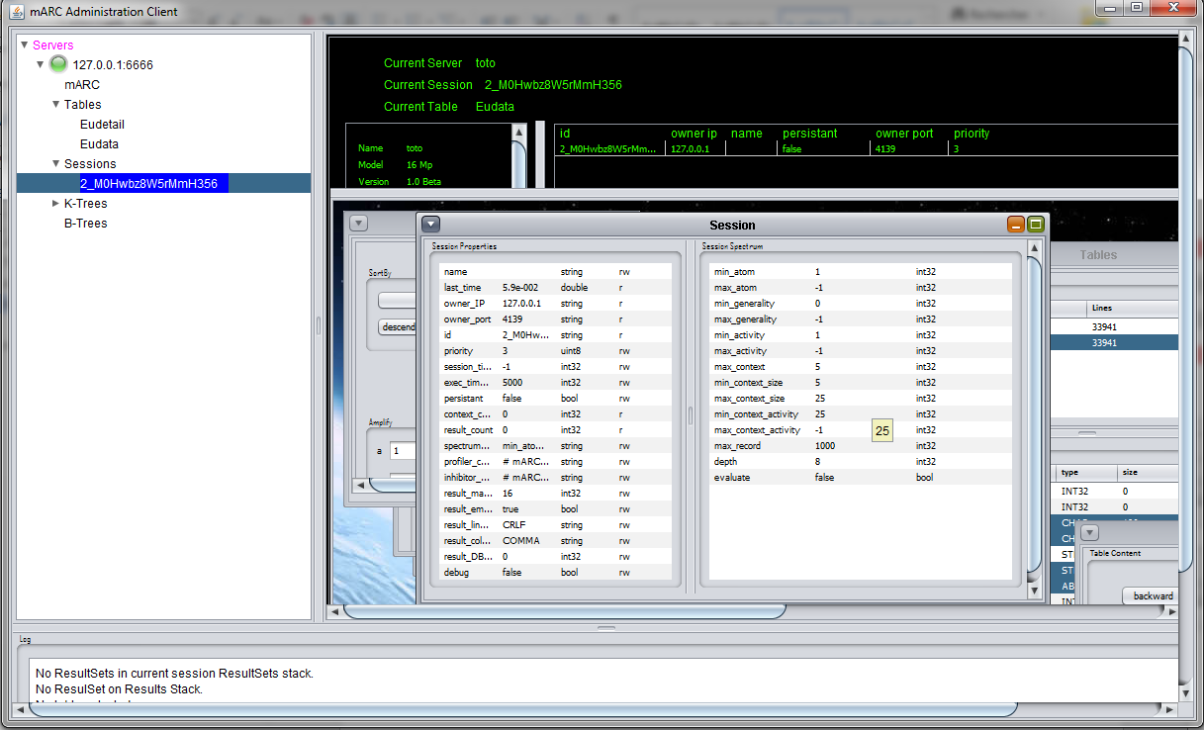

The session selected becomes the active current session and its properties and spectrum are in displayed and accessible.

# 3. Managing tables

The “Tables” node on the left tree may be managed through the “Table” tab window. You have first to select one of tables, if any:

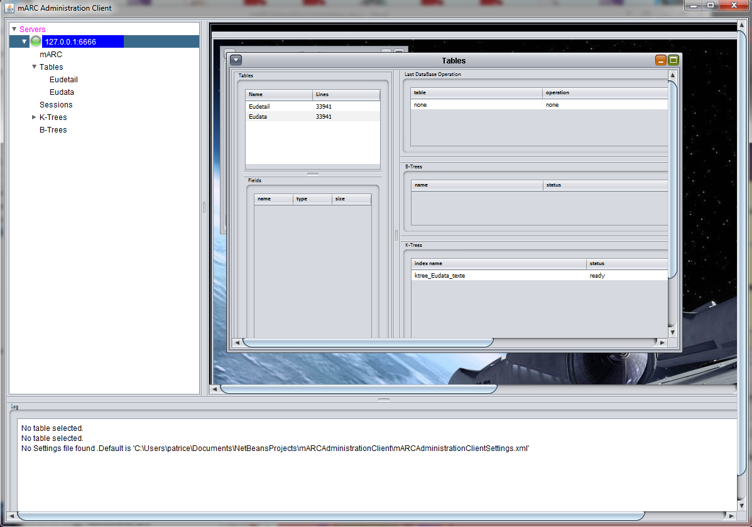

We see here that the server has 2 tables instantiated: “Eudata” and “Eudetail”. To select the master table “Eudata” just left click on it in the tree or the table line in “Tables” window:

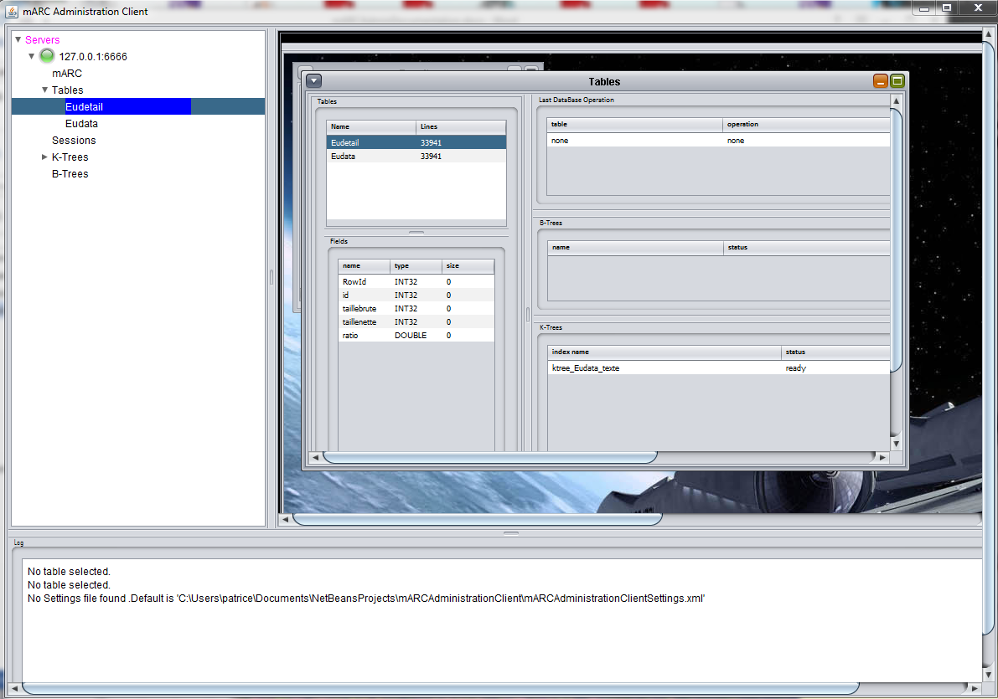

Its structure shows in and you may select fields you need to display:

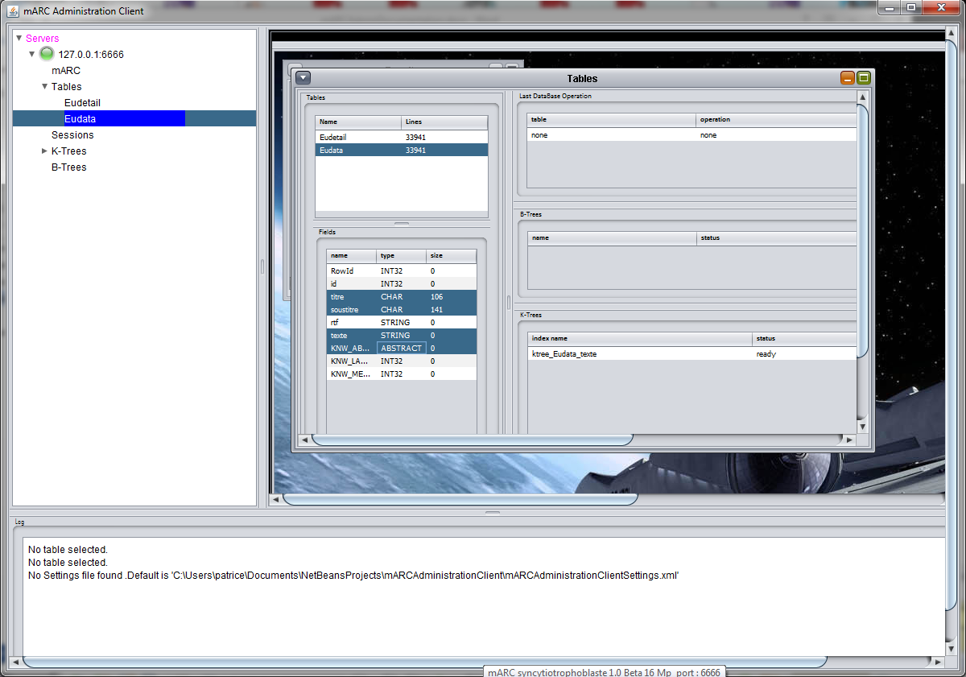

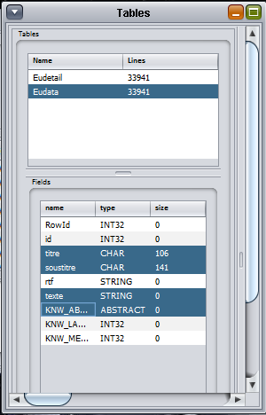All features of the selected table show in: its fields and the B-trees and K-trees if any. To manage a table select fields you need to display:

And left click on the table to display the content of the selected line for a given field:

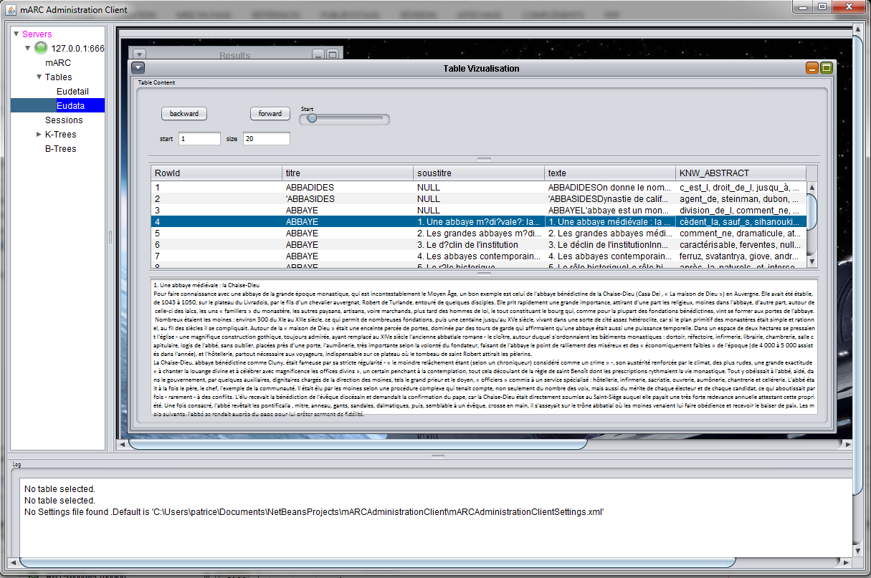

On the upper left window you see the content of the selected fields of the selected table. The slider allows you to scan all the table as the “Forward” and “Backward” buttons. Set the start of the scan and its size with text fields “start” and “size” by entering the desired values and pressing the “Enter” key:

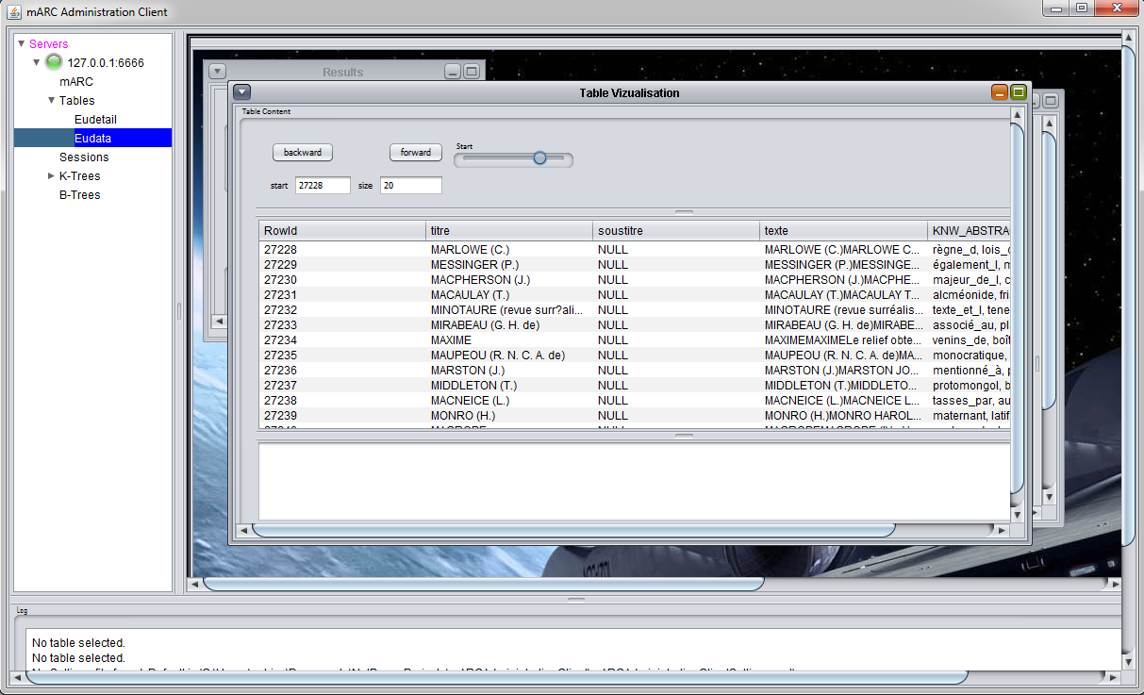

## 3.1 contextual menu

Right clicking on a line of the shown content table, a contextual menu shows in and allow you to perform actions on the table:

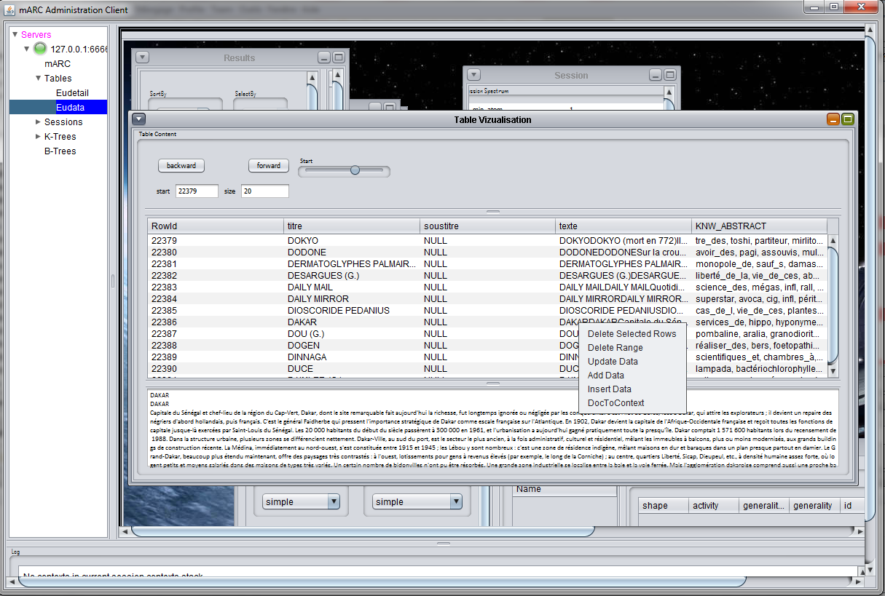

As an example, if we select “DocToContext”, the server creates a new context on the contexts stack, containing the contextual footprint of the document we selected (here document #22386) (cf section 4):

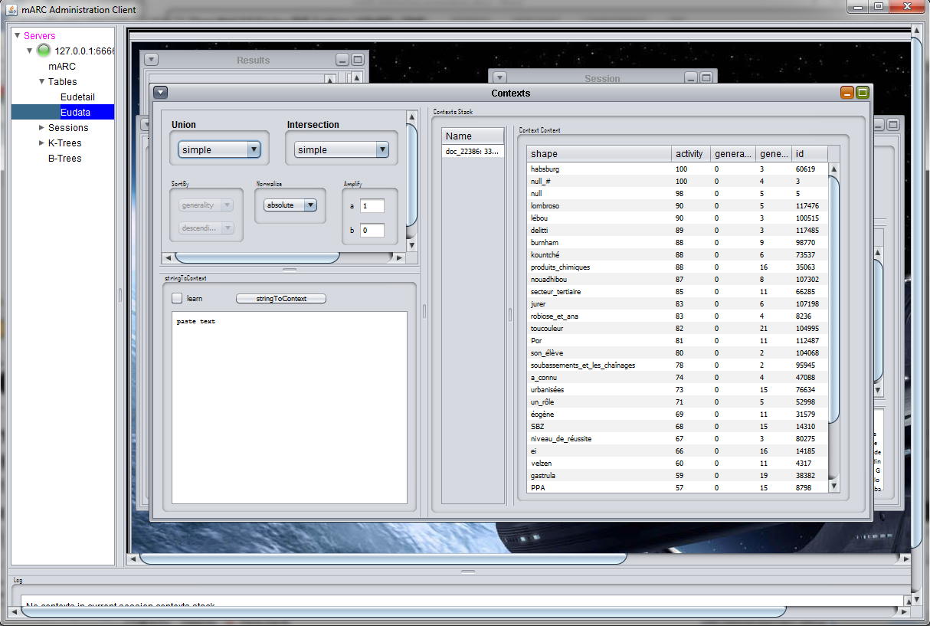

# 4. Handling Contexts

To handle Contexts, you need first to get a working session (cf section 2). To handle contexts select the “Contexts” window:

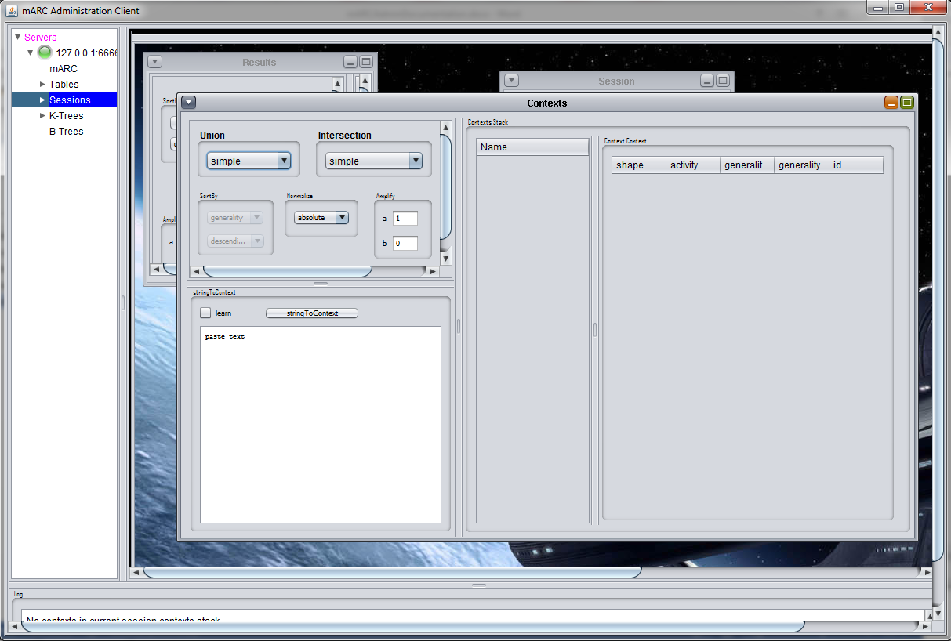

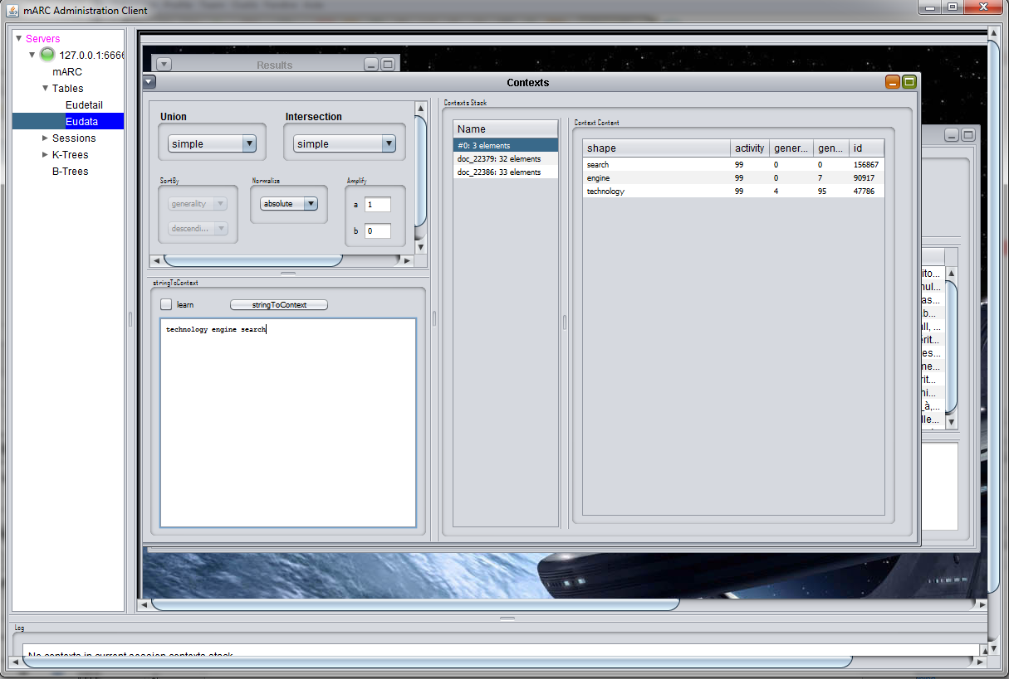The upper left part of the window is devoted to the API functions parameters handling contexts. The middle part of the window shows the contexts stack of the current session and the right part shows the content of the selected context of the contexts stack. Starting from the “DocToContext” action of previous section, we perform another “DocToContext” and we use “stringToContex” to create a new context on the contexts stack:

Selecting a context on the contexts stack, we can access a contextual menu:

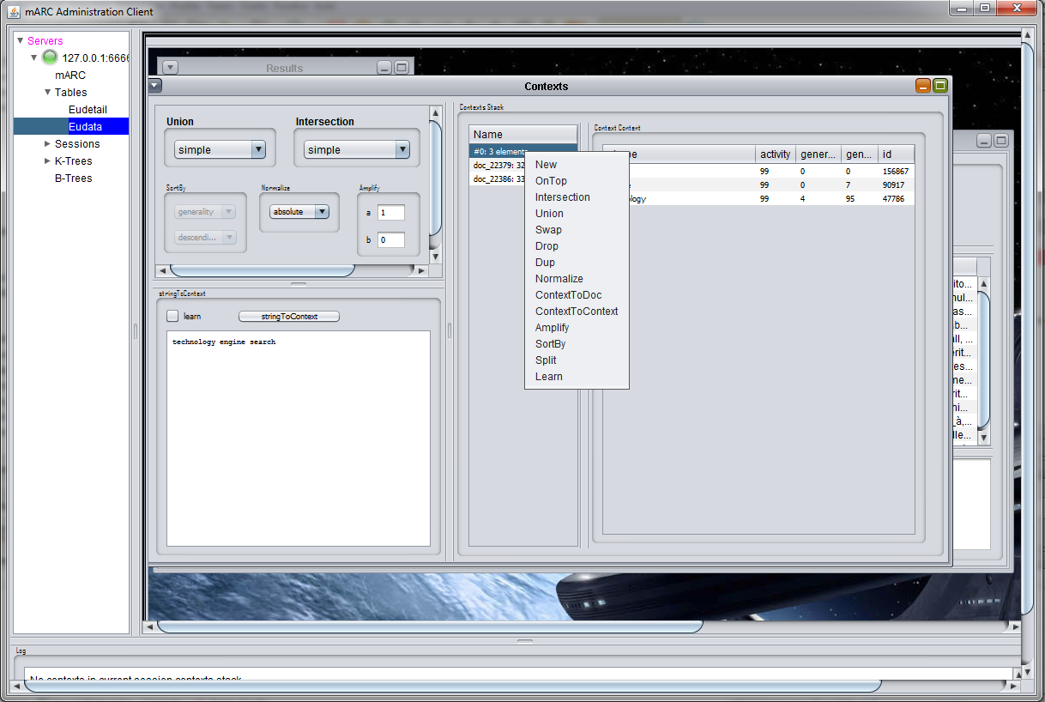

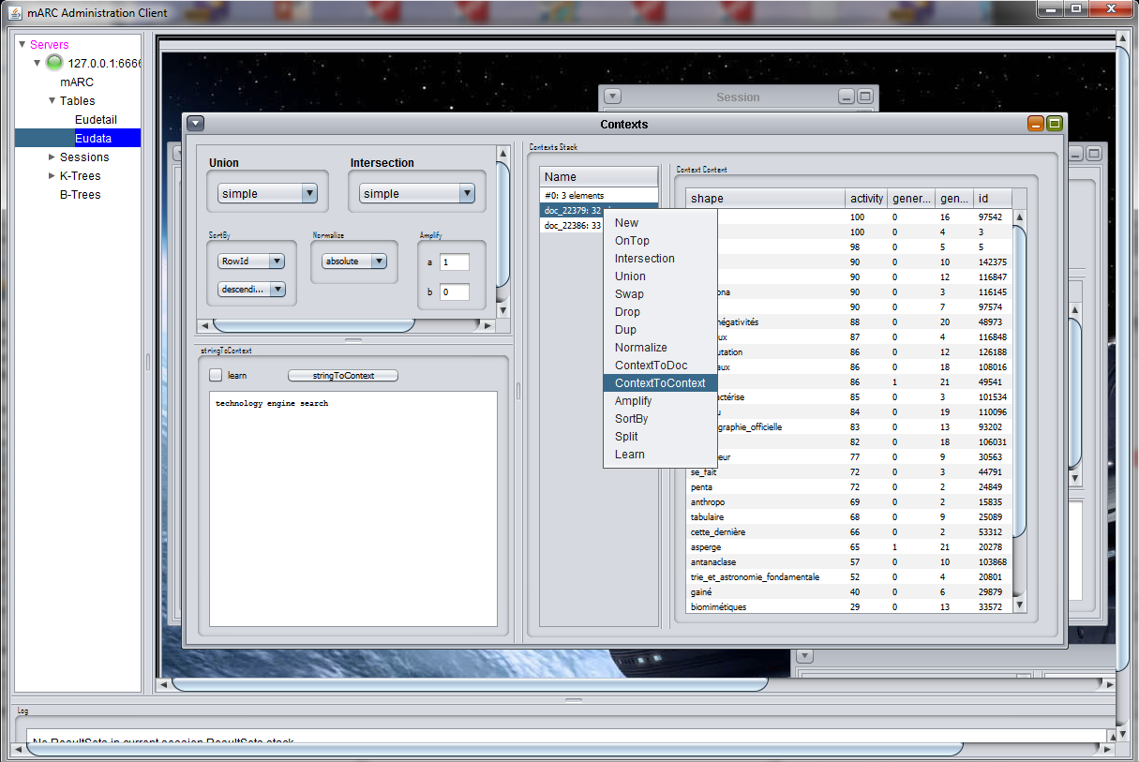Selecting second context on the stack:

We perform a contextual analysis:

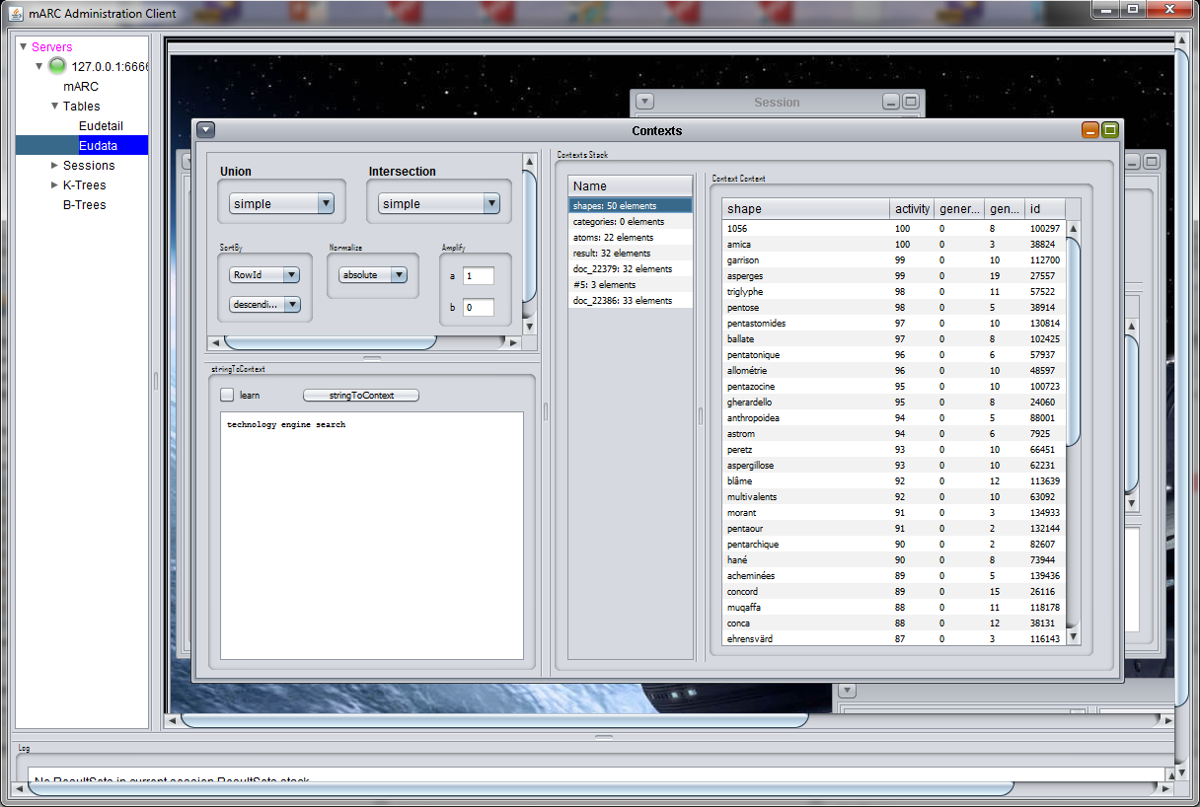

Selecting three of them, we can compute the union:

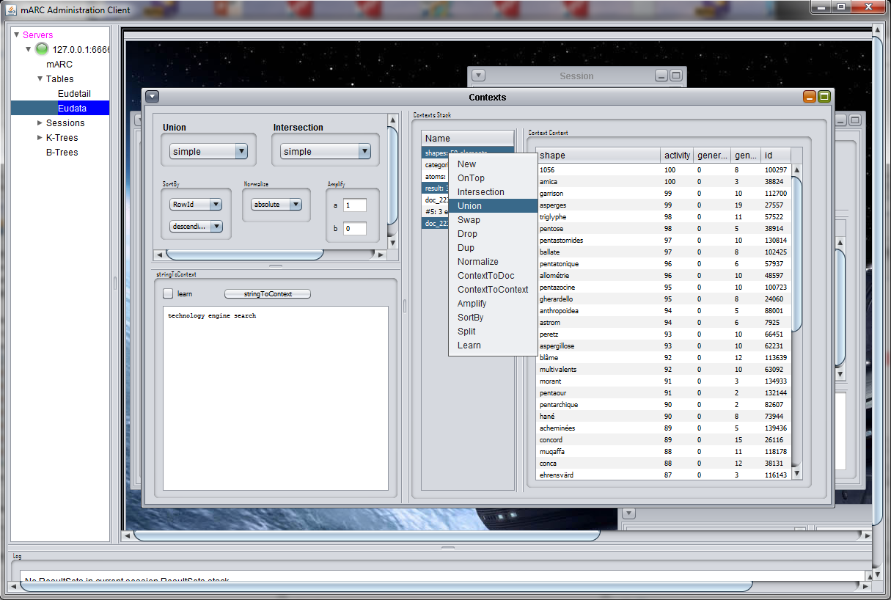

To obtain:

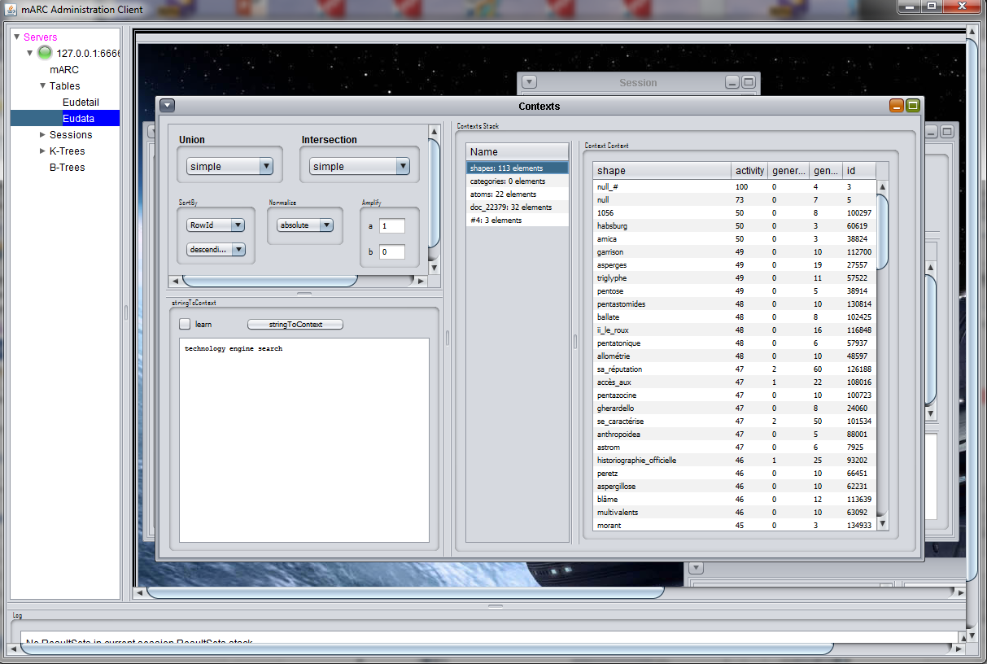

5. Handling Result Sets

Starting from first context on the contexts stack, we perform a “ContextToDoc” to retrieve all documents containing this context: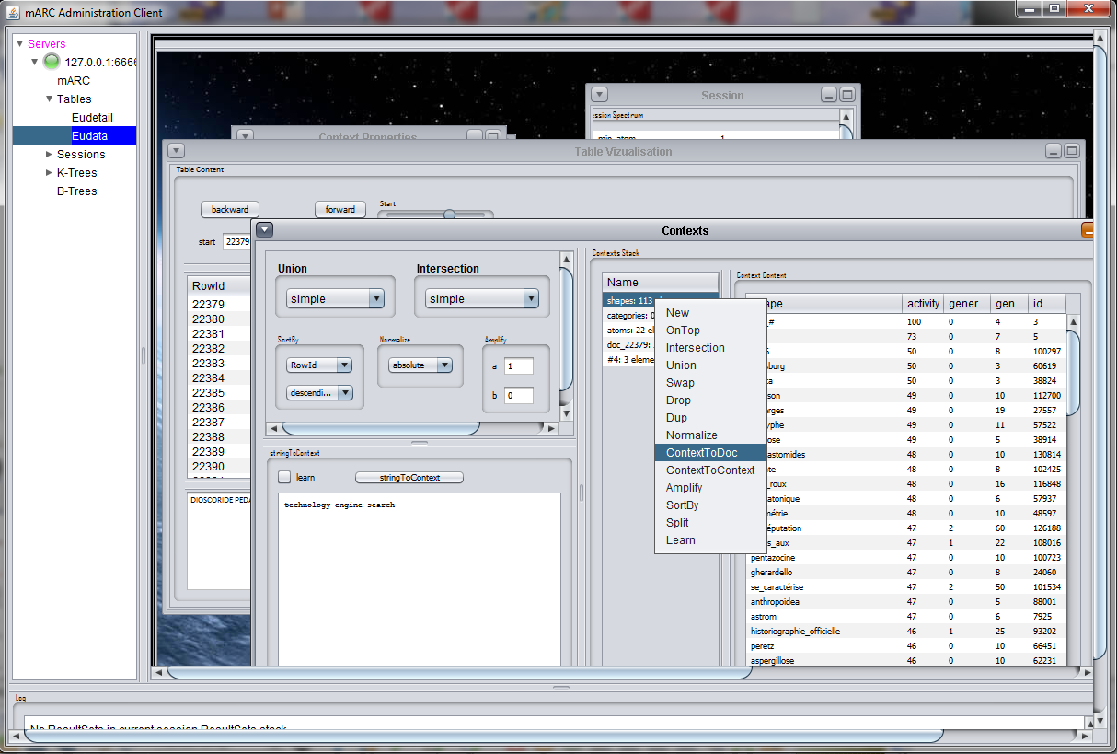

A new Result Set is created on top of the Result Sets stack:

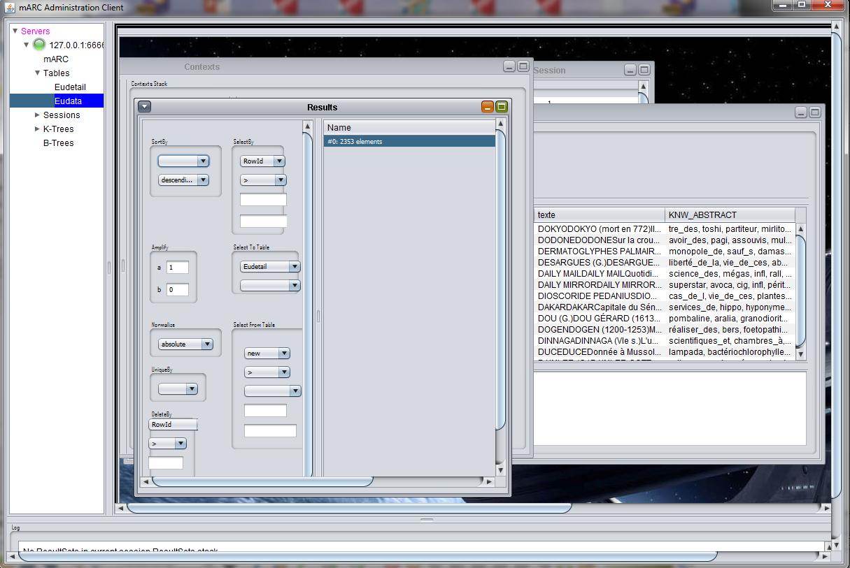

We can modify the properties of the current Result Set:

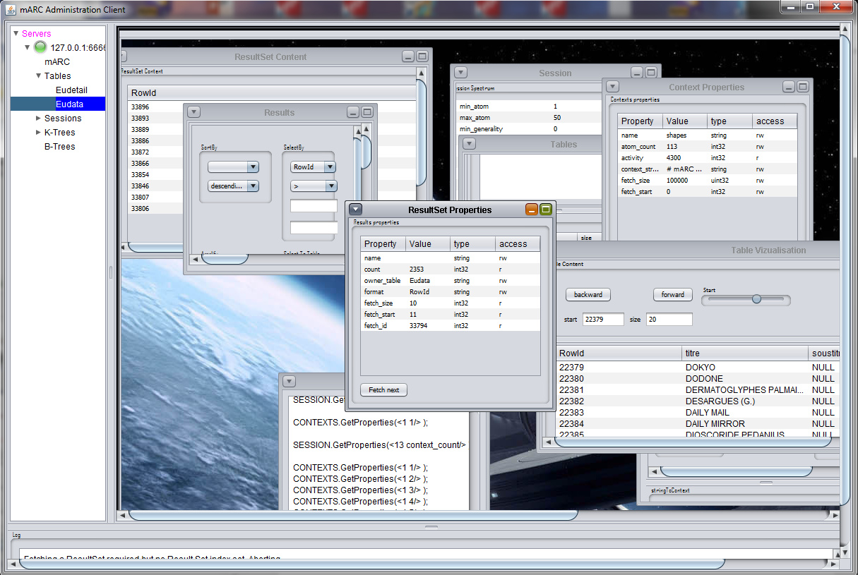

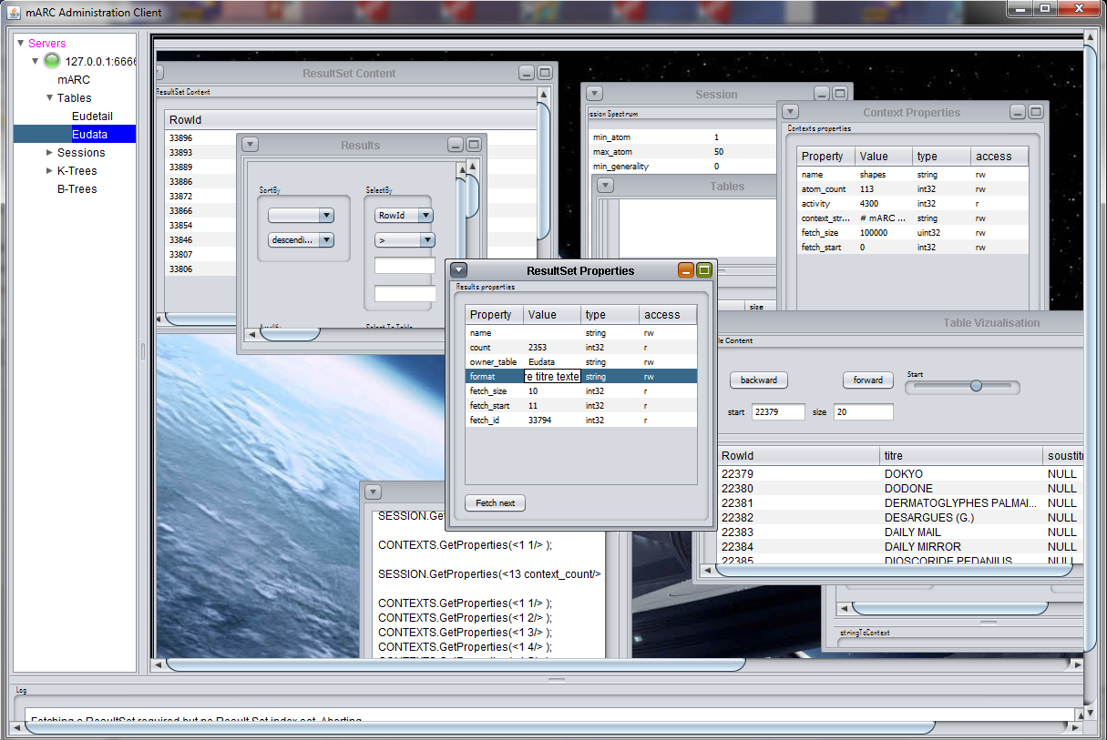

Changing the “format” property from its default value “RowId” to “RowId titre soustitre texte” allows to get:

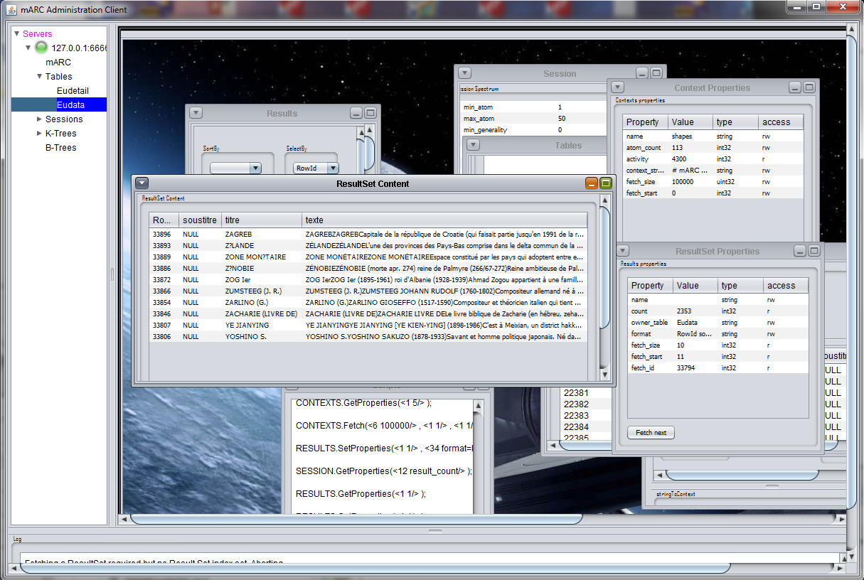

Right clicking on the result sets stack, we access the contextual menu to handle result sets:

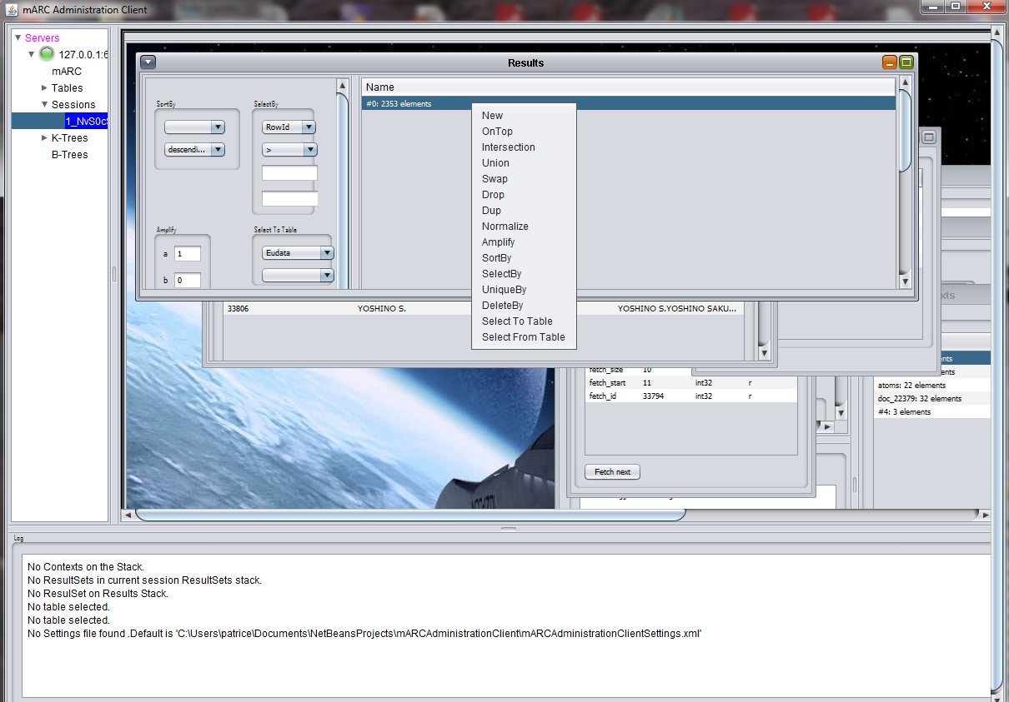

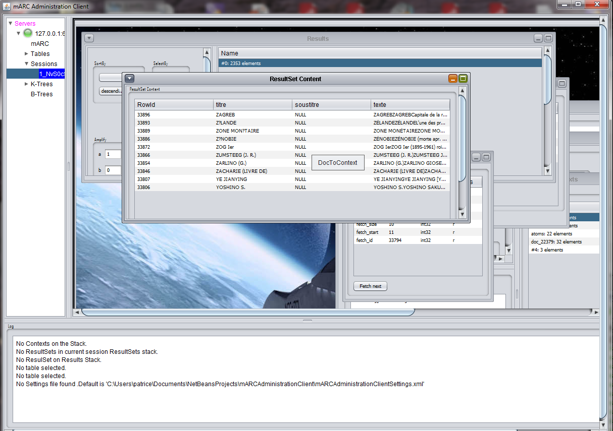A contextual menu is accessible by right clicking on the Result Set Content window:

Which allows to retrieve the contextual footprint of a document inside the current Result Set and add it as a context on the contexts stack.

# 5. Handling Result Sets